Create a Simple Pipeline (Amazon S3 Bucket) – Refer below for more Tutorials

https://docs.aws.amazon.com/codepipeline/latest/userguide/tutorials-simple-s3.html
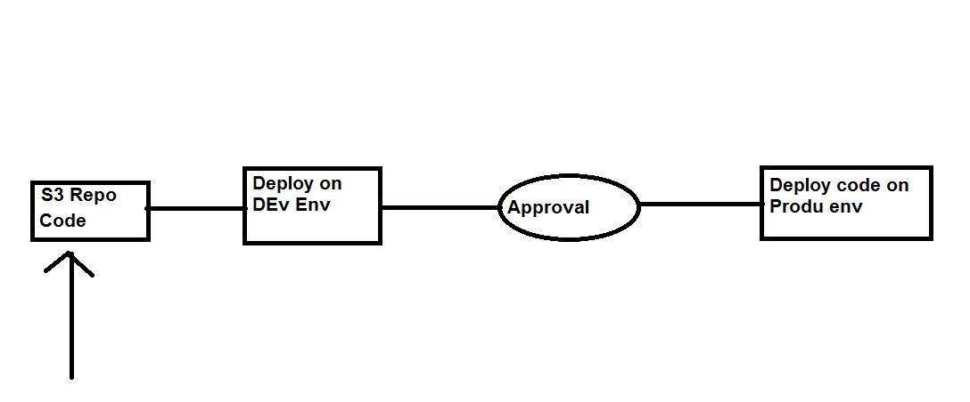

Step 1: Upload the Code to be deployed on the Dev/Prod Env in to S3 Bucket from the below github
https://github.com/awslabs/aws-codepipeline-s3-aws-codedeploy_linux

Step 2: Create 2 EC2 instance with CodeDeploy Agent and the required IAM policy to access S3 bucket.

Step 3: Create AWS CodeDeploy Resources to Deploy the Sample Application on the First EC2 instance (Dev Env)
s3://aws-codedeploy-us-east-1/samples/latest/SampleApp_Linux.zip – Link to the sample code.

Step 4: Create AWS CodeDeploy Resources to Deploy the Sample Application on the First EC2 instance (Prod Env)
s3://aws-codedeploy-us-east-1/samples/latest/SampleApp_Linux.zip – Link to the sample code.

Step 5: Create AWS Codepipeline with above workflow as in the diagram.

Step 6: Add some content in the sample bundle that was uploaded in the S3 bucket, and upload it again with the same name.

